3/9/2018

Part 3 Documentation

CSE 487/587

Spring 2018

Gursimrat Singh

[gsingh37@buffalo.edu](mailto:gsingh37@buffalo.edu)

50212333

Palwinder Singh

[palsingh@buffalo.edu](mailto:palsingh@buffalo.edu)

50247454

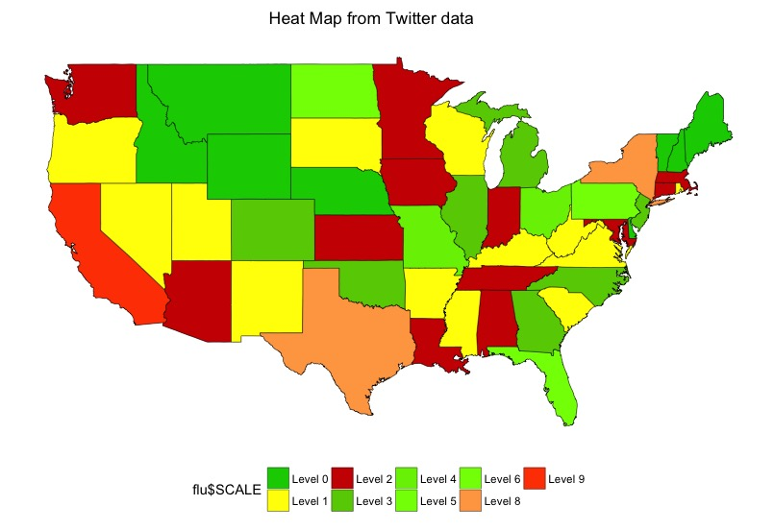

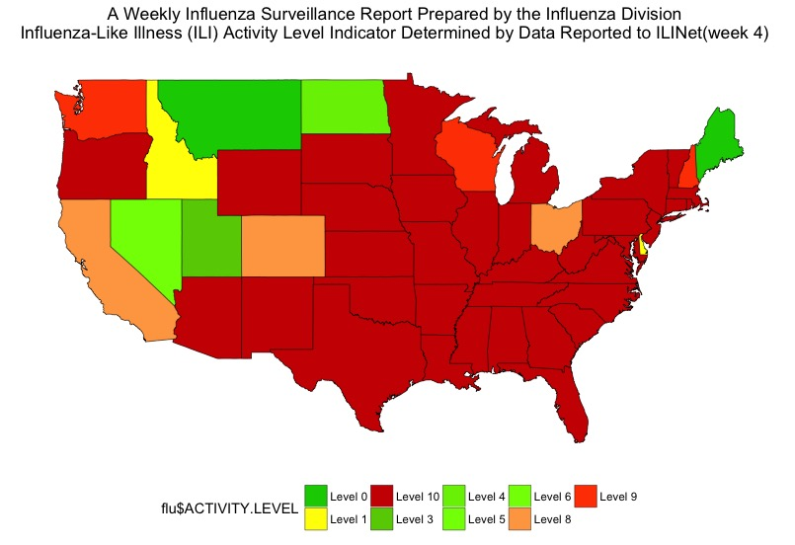

Level Values :

|  |  |
| --- | --- |
| Range | Level |
| 0 to 5 | 0 |
| 6 to 20 | 1 |
| 21 to 40 | 2 |
| 41 to 60 | 3 |
| 61 to 80 | 4 |
| 81 to 100 | 5 |
| 101 to 130 | 6 |
| 131 to 150 | 7 |
| 151 to 200 | 8 |
| 200 and ABOVE | 9 |

We can clearly see that the graphs are very different. The number of tweets doesn’t determine any relation to actual flu cases.